**1. How does your model/algorithm work?**

* Be able to explain your method (e.g. word2vec, random forest, CNN) to a non-technical audience concisely.

The progressive growing of GANs trains the GAN network in multiple phases. In phase 1, it takes in a latent feature z and uses two convolution layers to generate 4×4 images. Then, we train the discriminator with the generated images and the 4×4 real images. Once the training stables, we add 2 more convolution layers to upsampling the image to 8×8 and 2 more convolution layers to downsampling images in the discriminator.

The progressive training speeds up and stabilizes the regular GAN training methods. Most of the iterations are done at lower resolutions, and training is 2–6 times faster with comparable image quality using other approaches. In short, it produces higher resolution images with better image quality.

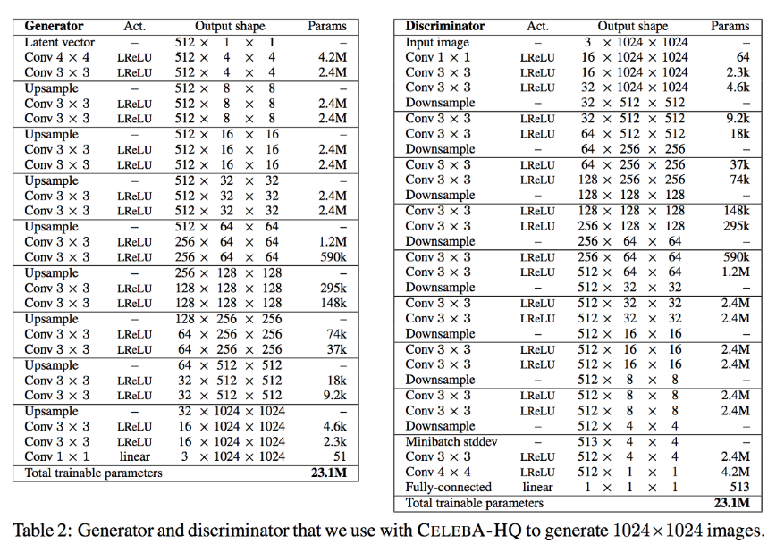

When new layers are added in each phase, it will be faded in smoothly with weight α gradually increases linearly from 0 to 1 below.

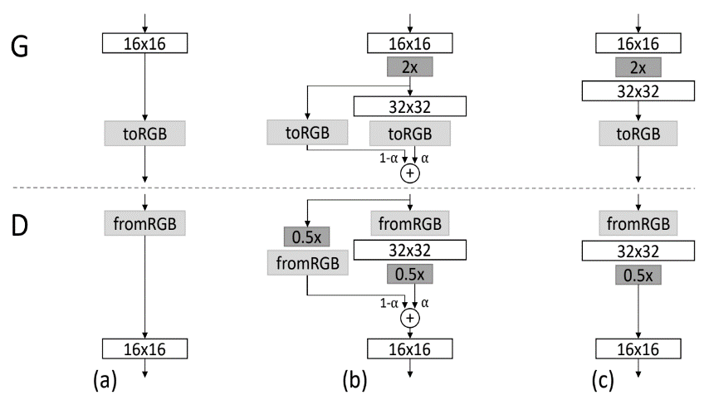

**2. Why did you choose this model?**

* Does it work? Better than chance? How much better? 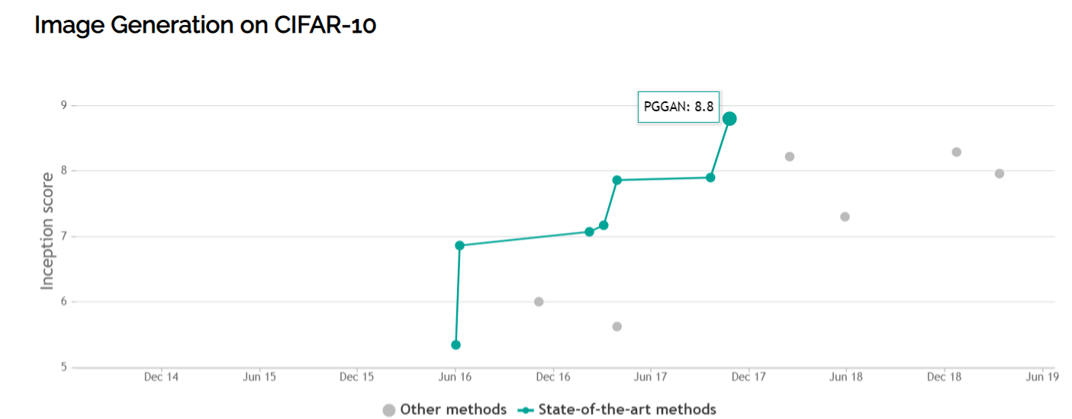
* 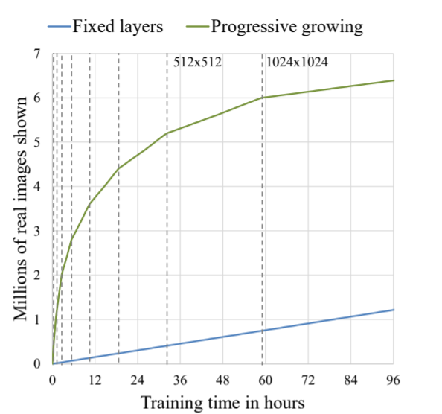
* Is it the best choice? Better than simplest option? How much better? What value did you add by using this model?

GANs currently generate the sharpest images but they are more difficult to optimize due to unstable training dynamics. PixelRNNs have a very simple and stable training process ([softmax loss](https://en.wikipedia.org/wiki/Softmax_function" \t "_blank)) and currently give the best log likelihoods (that is, plausibility of the generated data). However, they are relatively inefficient during sampling and don’t easily provide simple low-dimensional codes for images. All of these models are active areas of research and I am eager to see how they develop in the future!

* Understand the trade-offs between interpretability and predictive power.

???

* Know your confusion matrix. Know what you optimized for and why: Precision, recall/sensitivity, etc.

GANs models are optimized to achieve both precision and recall. I.e The networks are trained for achieving how realistic they are to the original sample data and How much diverse they are, and to calculate this current method is to find FID score or Inception score.

**3. What are assumptions of the model?**

* How and why did you pick training and testing sets?

The training count of images are 4000 for landscape and 1000 for abstract. This assumption was based on the standard dataset(CIFAR) which has 5000-6000 images for each class.

* Did you assume normal distribution?
* Know how you would make it better / test assumptions

To generate better image quality I need more training time with higher pixel dataset.

**4. Did you try other parameters / features / etc? (the answer should be yes)**

Which features were most important? Did you engineer any features?

I initially started with lower number of epochs to see if the model is working or not. Once my loss was decreasing with the number of epochs, I started incrementing epochs till the model can successfully generate images.

I also trained proGAN on two different loss function, one is BCE and WGAN-GP, and WGAN-GP was better at training NNs by finding better similarities between original and generated images.

**5. How did you validate this? What is your metric for success?**

**Getting lower FID score is the metric for the success of my model.**

*Lower FID values mean better image quality and diversity.*

In FID, we use the Inception network to extract features from an intermediate layer. Then we model the data distribution for these features using a multivariate Gaussian distribution with mean µ and covariance Σ. The FID between the real images x and generated images g is computed as:

https://cdn-images-1.medium.com/max/1000/1*tJmwViZesuFM89TcVN7J3A.png

* Did you achieve your goal? This requires you to define your metric for success. Often non-trivial, but IS data science.

The easiest way to define success is to see real images and tell if they look realistic or not. Also I achieved FID score of 7.2 for the generated landscape dataset and average FID for CIFAR is 5. Lower the FID score better the image generation.

* If validation is challenging or difficult, how would approach it if you had the right data?
* Need to look at graphs and understand product to define metric properly - did you do analytics?
* 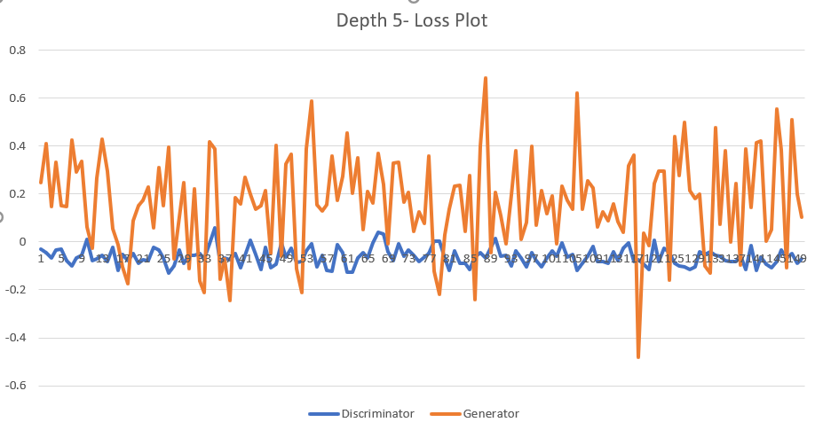

**6. Do you know your data?**

* What were the limitations of your data?

It can only generate landscape abstract images

* Be able to explain every feature of your graphs

**7. Generalizability and next steps**

* How does your product generalize to other use cases or audiences?

GANs are heavily researched for their use case in **cybersecurity** to detect crimes

Video Synthesis in different language can increase the productivity of YouTube channel

* How does your project relate to our company?

Yes, for shopify GANs can learn the adversarial attacks and can get better at bot detection

* What would you do if you had more time?

Controlling generation of images using style GANs

Trained higher quality images

Adding a feature to upload two images and transfer one image style to another image.